**Author: Anurita Chatterjee**

**Date:16-03-2022**

**WhatsApp Pay**

**STAKEHOLDERS**

|  |  |
| --- | --- |
| **ACTOR** | **What he can do on the Software Created** |
| WhatsApp users | * Users can transfer the money to the family, friends during chatting with them through WhatsApp * Users can use their debit/credit card into WhatsApp * One-click fast payment * Easy and user-friendly interface |
| Banks | * Manage the bank accounts of users * Verify requests from payment systems (MasterCard, VISA, etc.) * Sends an authorization code that approves the payment system to complete the payment |
| Credit card providers | * Allow to use credit card for money transfer in WhatsApp pay application * Payment system receive request to approve transfer * Analyse user reputation and analyse the term of money transaction * Receive authorization code from bank or rejection of transaction * Send money to the seller's bank account or reject transfer * Send notification with payment confirmation |
| Bank (debit card provider) | * Allow to use debit card for money transfer in WhatsApp pay application * Payment system receive request to approve transfer * Analyse user reputation and analyse the term of money transaction * Sends an authorization code that approves the payment system to complete the payment * Receive authorization code from bank or rejection of transaction * Send money to the seller's bank account or reject transfer * Send notification with payment confirmation |

**Risk Identification**

* Issues with payment gateway security
* Issue with connection between bank, payment system and WhatsApp Pay payment gateway
* New payment system will be not such popular as we expected
* Unexpected system or server crashes
* Users will be scared to use payment app into WhatsApp (objections regarding security)

**SWOT Analysis of WhatsApp pay**

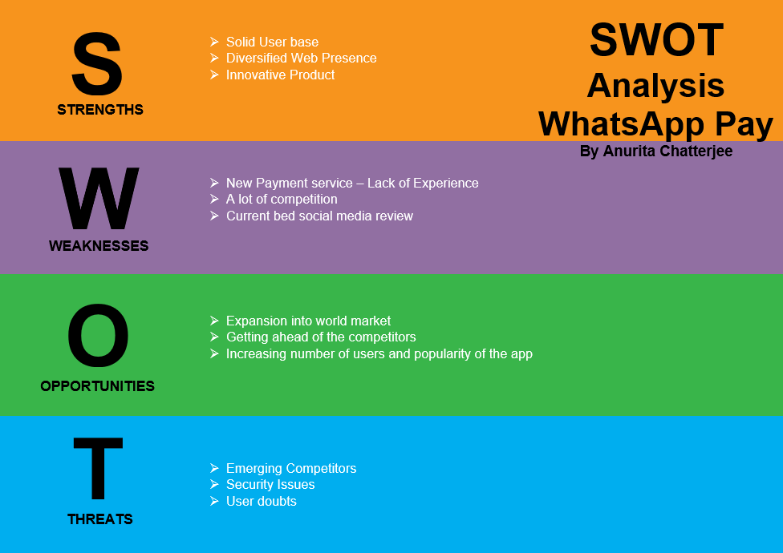

**PROPOSED SYSTEM**

What is the proposed solution or system? Mention in points how the system itself will be for the user.

* User friendly interface
* Self – explanatory
* Fast and easy to use money transfer
* One-click payment
* Digital payments
* Integrated credit/debit cards with WhatsApp app
* Possibility to easy peer to peer payments
* No need to use wallets, bank apps, NEFT to transfer money
* No need to install new app, it will be added as update to existing app

**Flowchart – Future state**

**SCOPE using Use Case Diagram (UML)**

**IN SCOPE**

* WhatsApp Pay feature – additional functionality to WhatsApp which allow to manage payments inside the app
* Payments with QR code – using QR codes instead of personal data to transfer money
* Update to WhatsApp – implementation new addon WhatsApp Pay as update to original app
* Security gate -to secure transfer money
* Payment gateway – to manage online transfers of money
* Security PIN – password which allow to make transfer by user

**OUT OF SCOPE**

* Launched in all countries at once
* Adding trusting contact to transfer money without security PIN

**Business Requirements:**

**Business Objective:**

* Have at least 1 milion users use WhatsApp Pay feature within the first 3 months of launch
* Over 1 year of its launch have 30% of user base using WhatsApp Pay

**FUNCTIONAL REQUIREMENTS**

* System allow to transfer money between users.
* Sender and receiver receive payment notification o their chat window
* Transfer on one click (transfer button)
* Secure transfer by using payment gateway and security PIN
* User can transfer money using credit/debit card
* User need only WhatsApp pay to transfer money

**NON-FUNCTIONAL REQUIREMENTS**

**System Requirement:** Windows or MacOS, internet connection, live server for payments management, auto scheduled tasks

**Usability:** user friendly screen, self-explanatory interface

**Environments:** highly secure, scalable and reliable, user-friendly, self-explanatory

**Screen Wireframes**

